**SPRING CORE NOTES**

IOC Containers:-

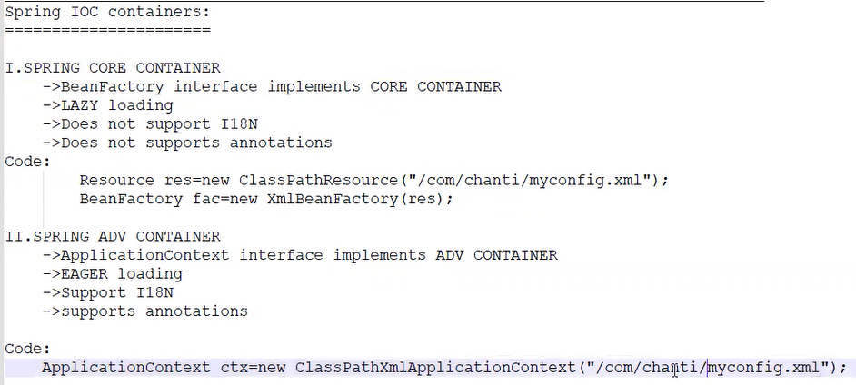

**MAIN class Code :-**

**package** spapp2;

**import** org.springframework.context.support.ClassPathXmlApplicationContext;

**public** **class** Myapp {

**public** **static** **void** main(String[] args) {

//implementing IOC contaner

ClassPathXmlApplicationContext context= **new** ClassPathXmlApplicationContext("Spapp2.xml");

//get bean from contener

MyBean2 bean2=context.getBean("myBean2",MyBean2.**class**);

MyBean1 bean1=context.getBean("myBean1",MyBean1.**class**);

//use bean from conterer with method

bean2.showMsg();

// close the ioc contaner

context.close();

}

}

Bean Autowiring:-

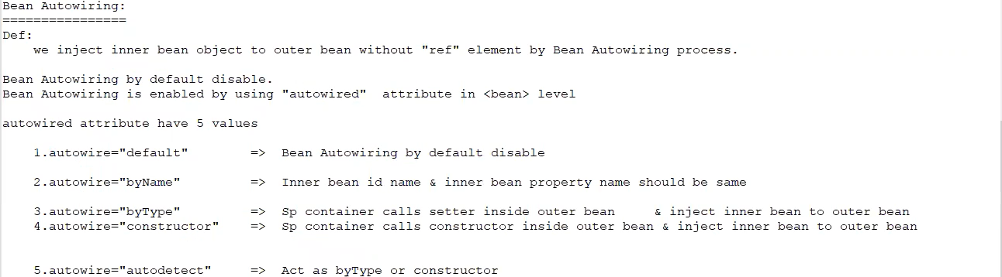

Ref element:-

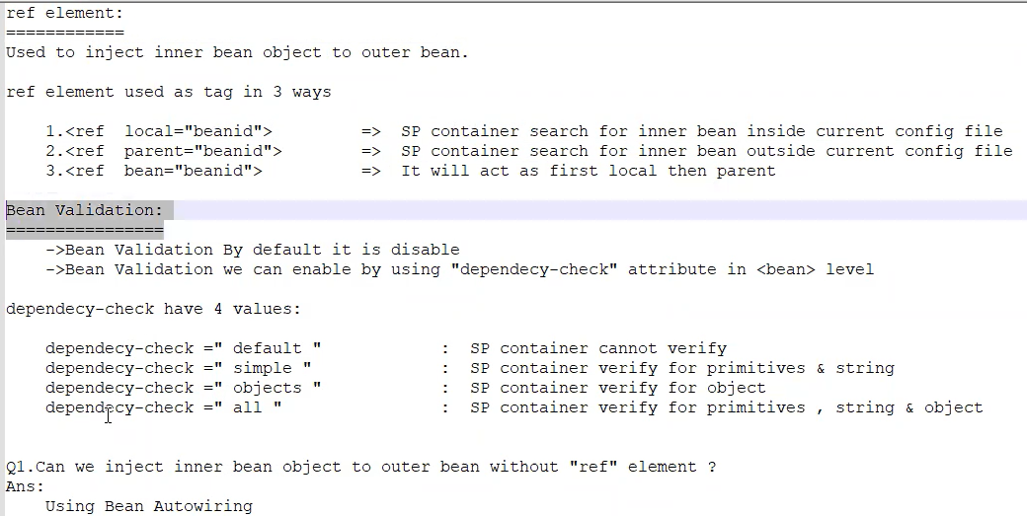  
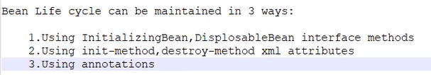

Bean Scopes:-

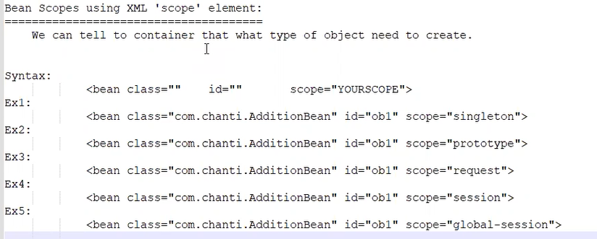

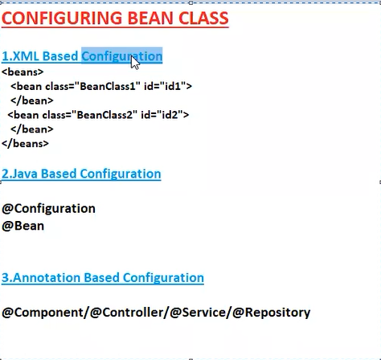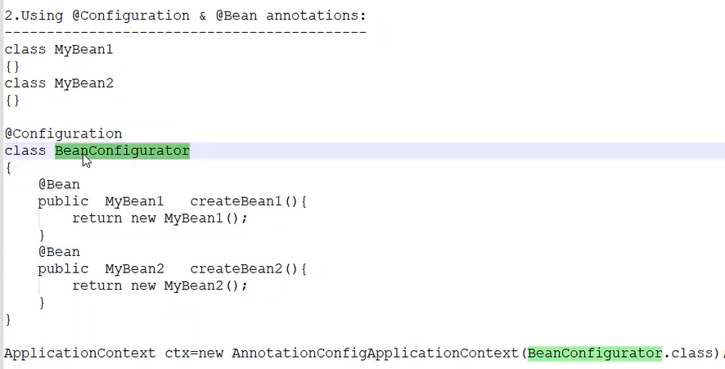

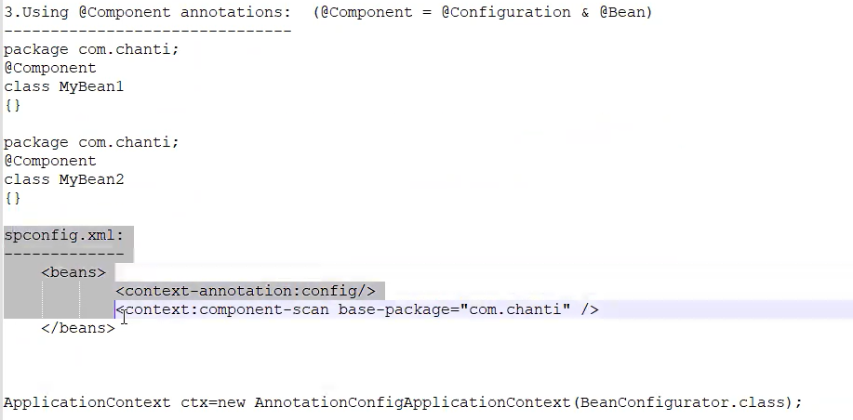

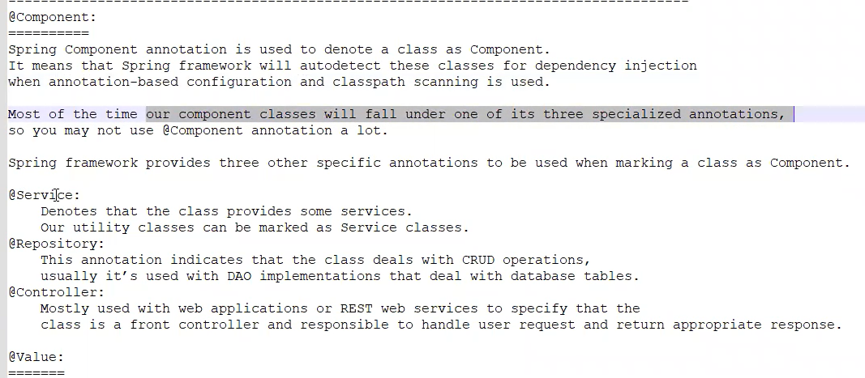

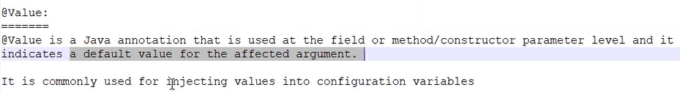

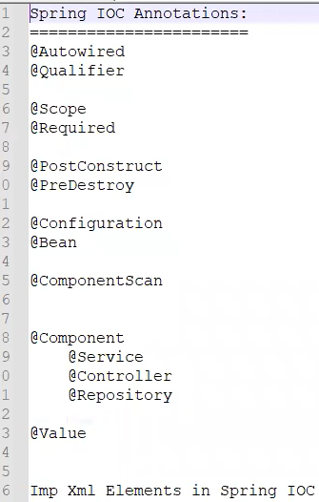

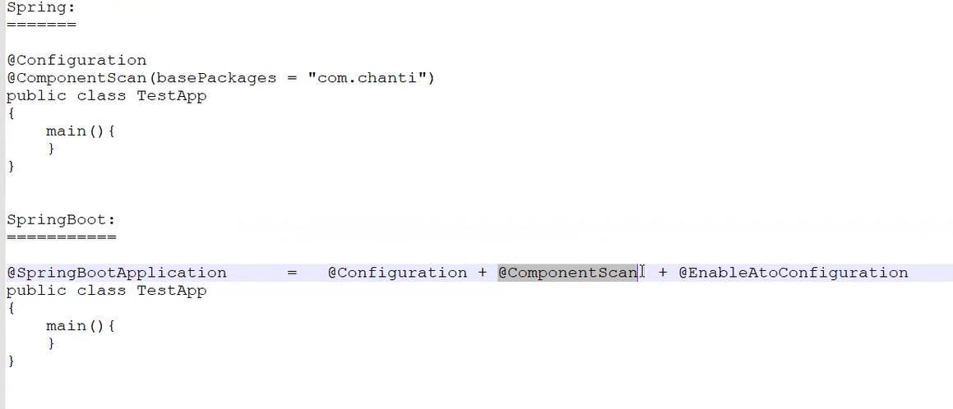

Coupling:-

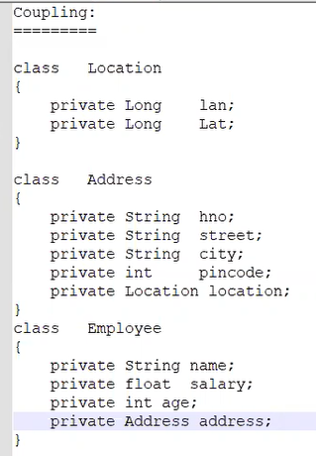

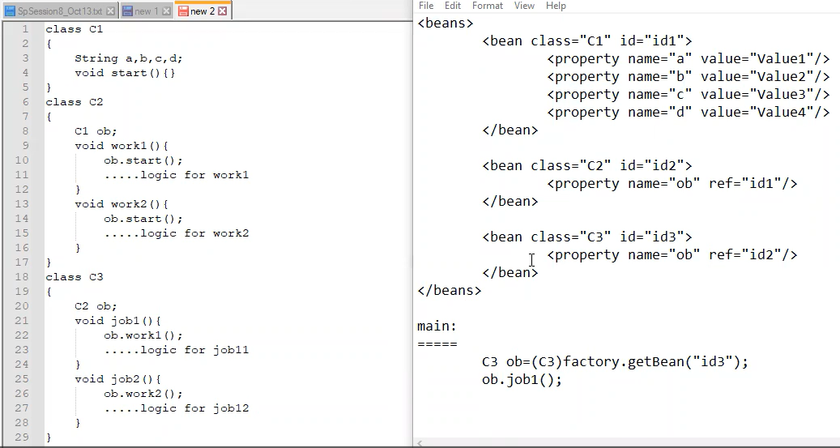

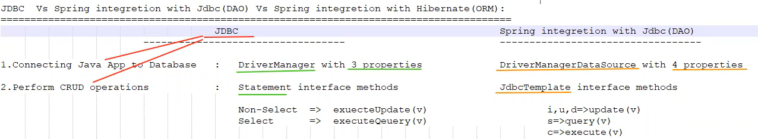

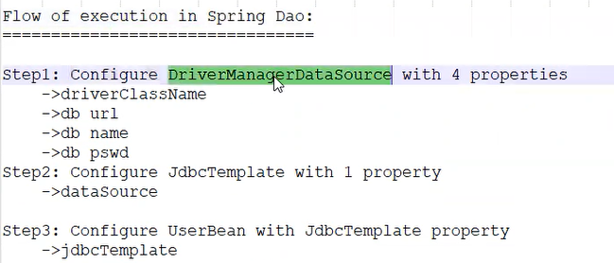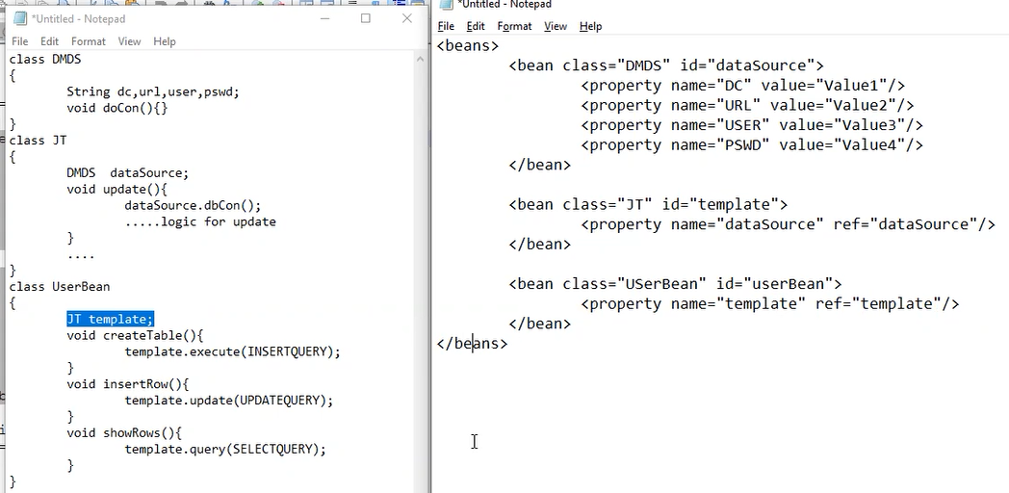

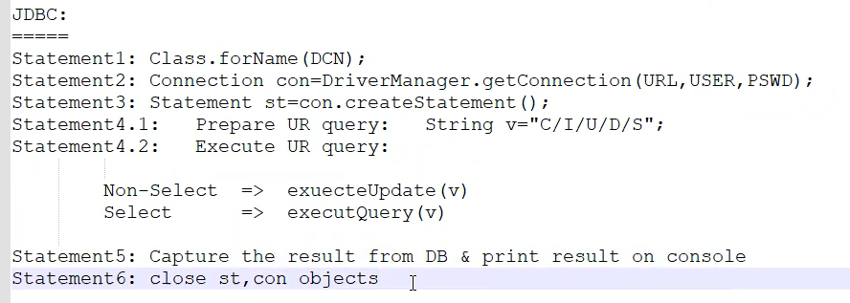

HIBERNATE:-

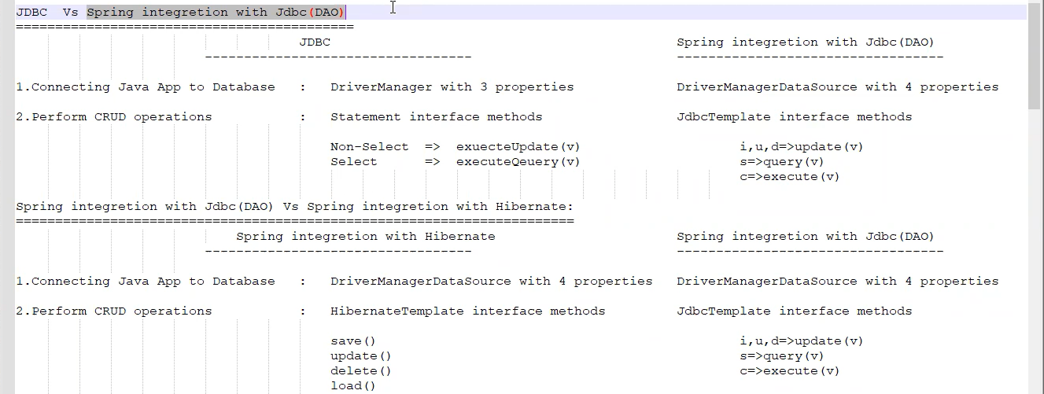

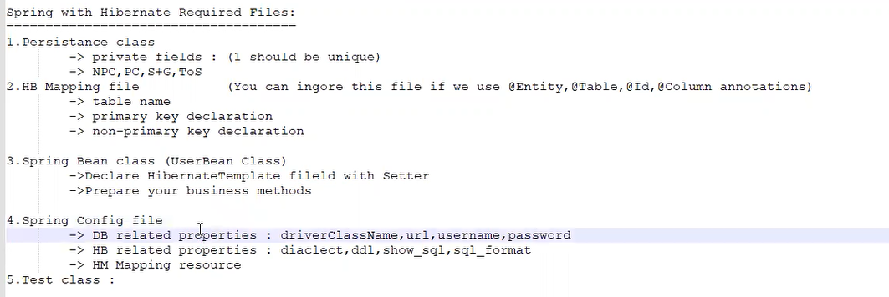

LocalsessionFactory Do:-

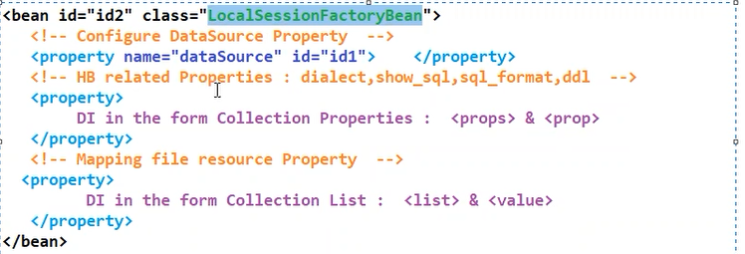

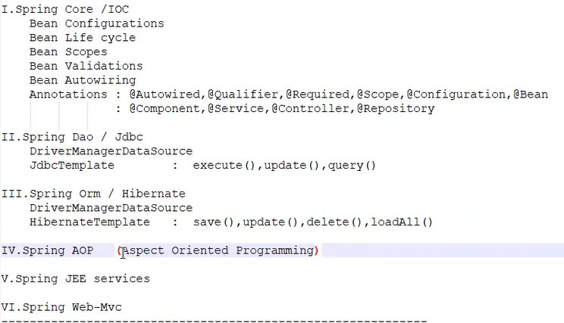

SPRING AOP:-

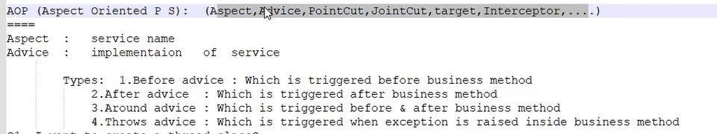

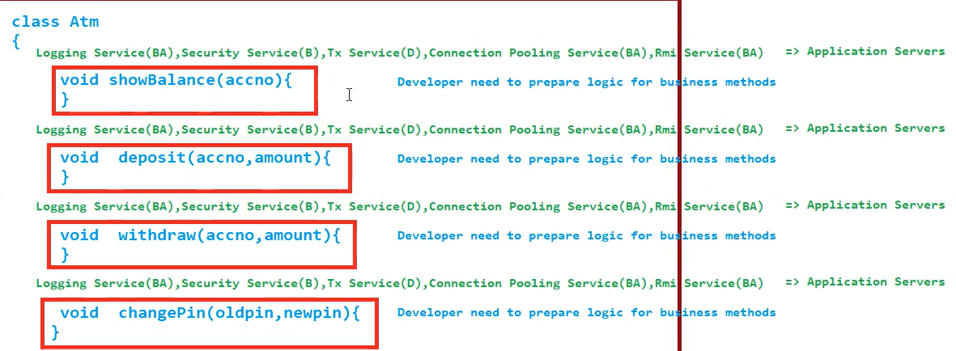

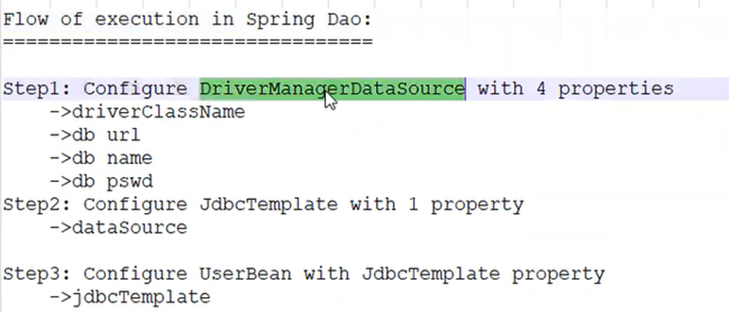

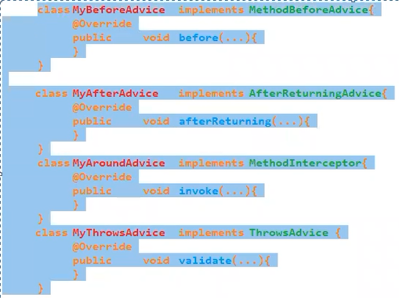

Flow OF AOP

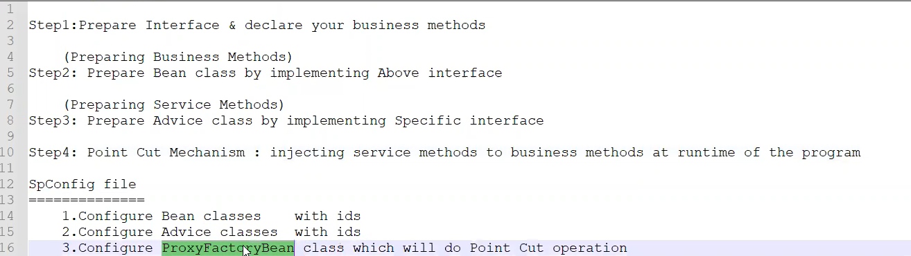

Flow of AOP

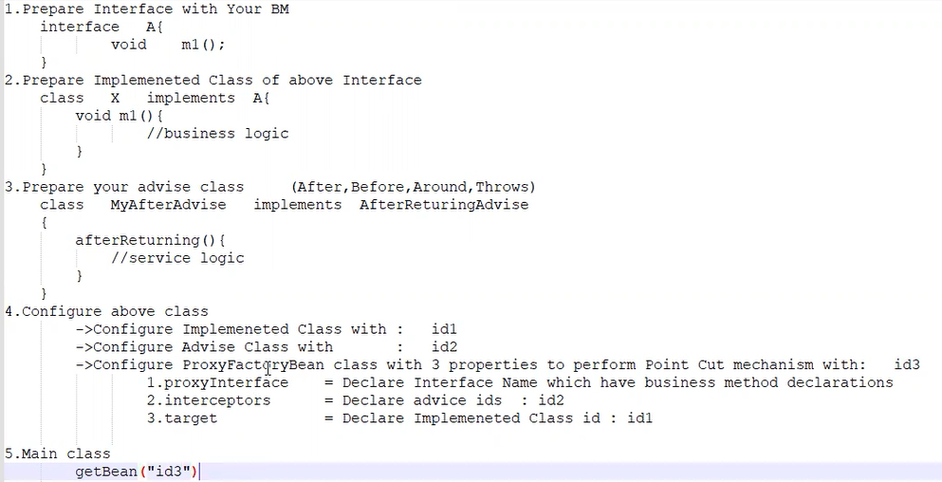

Config.xml:-

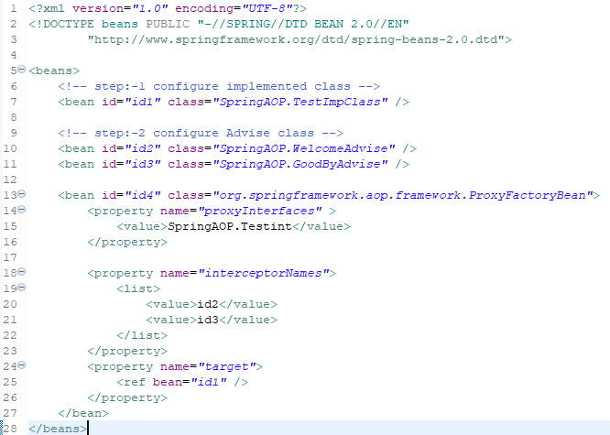

AOP USE

1.To print the logs before class and after class (Join point)

2. Use for print logs before method and after methods(point cut)

3.Use for advise(services aka methods) before & after class, Methods.

SPRING MVC

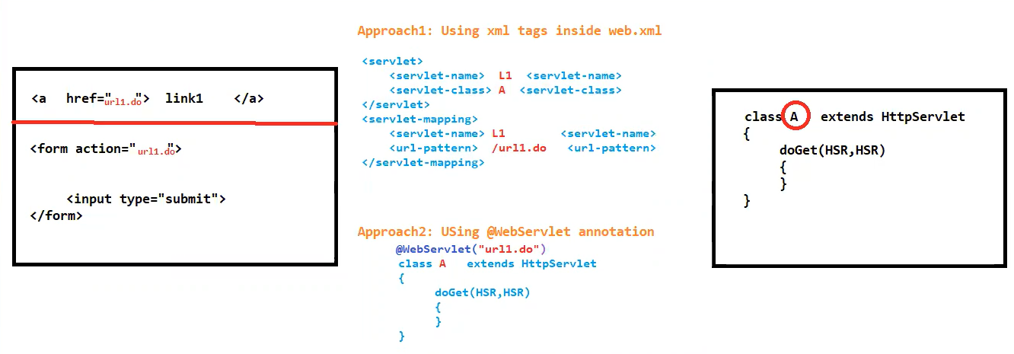

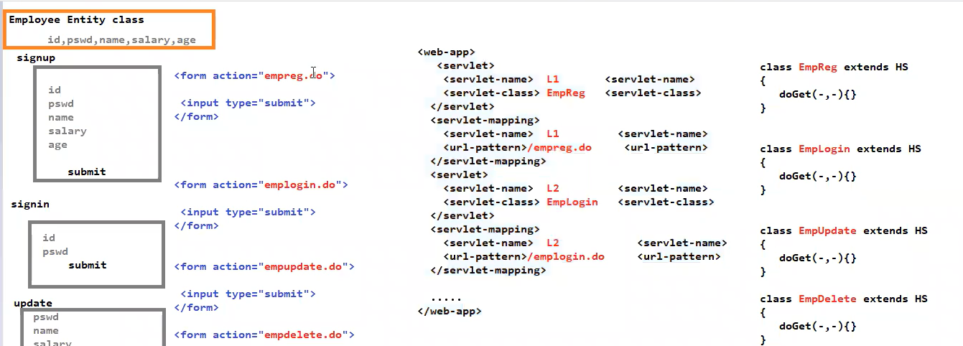

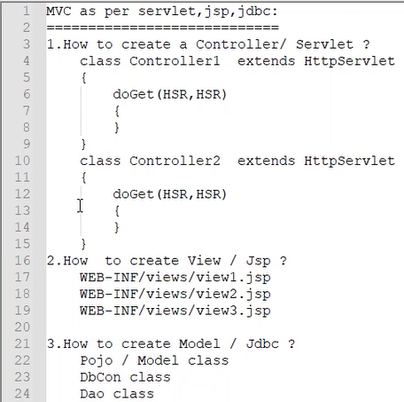

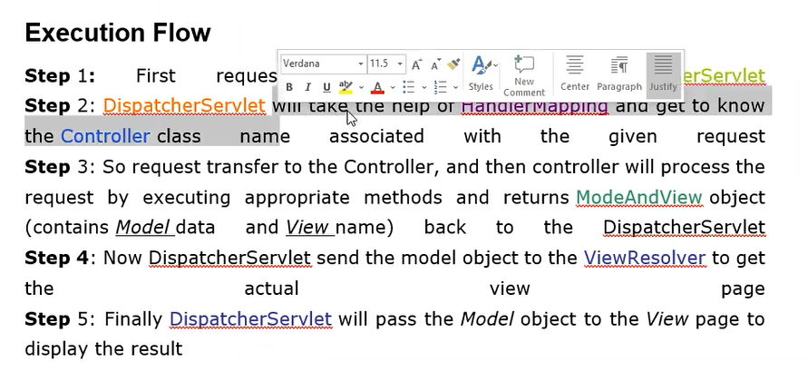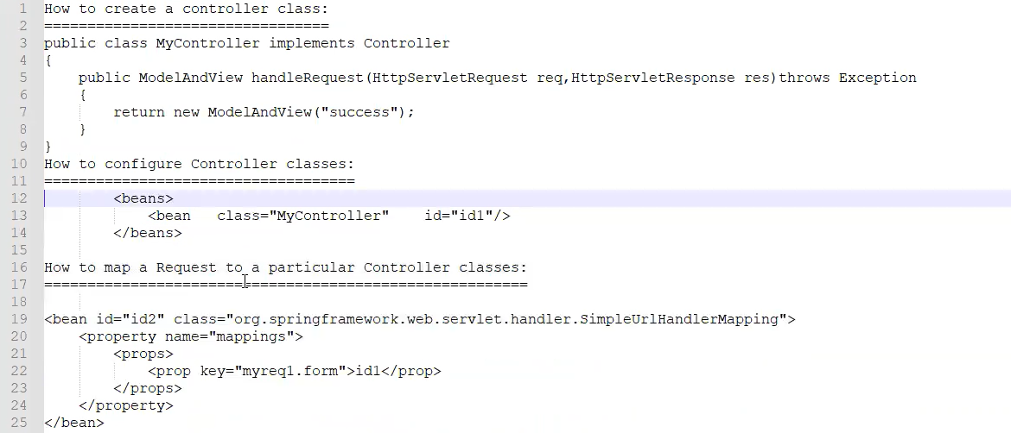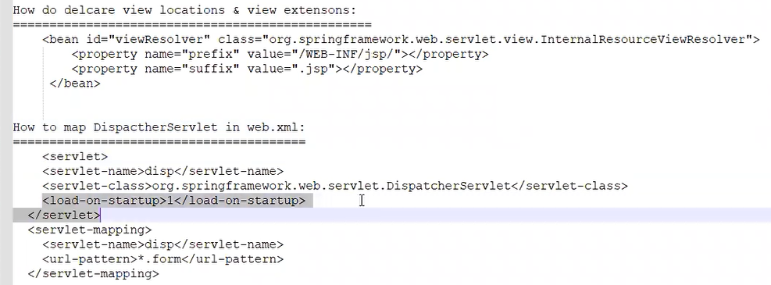

@controller annotation

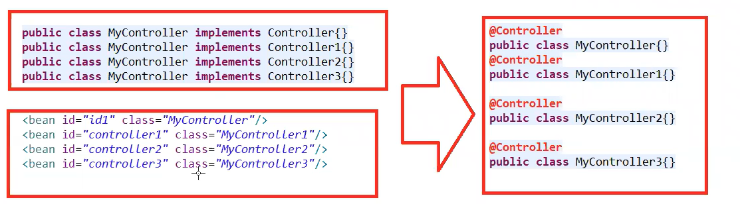

@requestmapping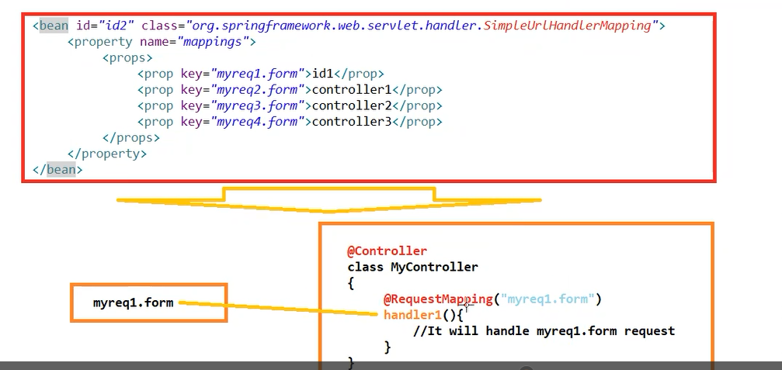

@requestparam

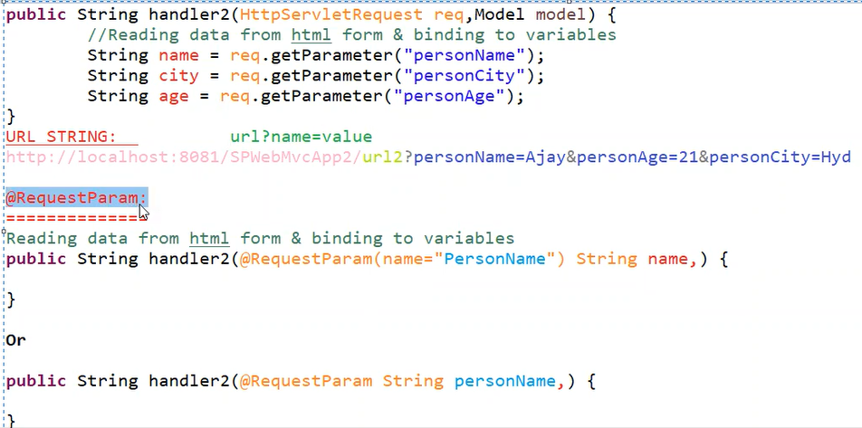

@modelAttribute

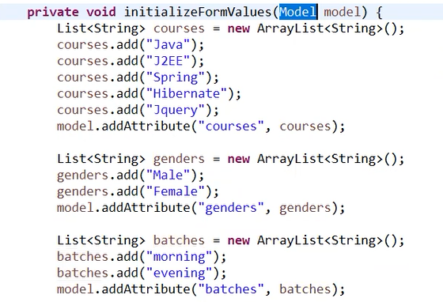

Listener :- Use to reduce load of servlet

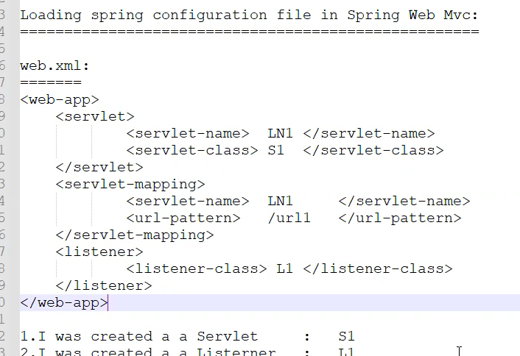

How to Import Maven project from website to eclipse:-

Step 1:- we have to set same JRE & JDK that we have in local system (From Build Path).

Step 2:-

Maven :-

1. Maven clean -> it will got to target folder and delete all .class & .jar(Use for only standalone project ) &.war(use for web projects)

2. Maven compile-> Compile all the source file then we get .class files in target folder

3. Maven test-> It will run all test cases

4. Maven package-> It will create jar or war file and store in target folder

5. Maven install ->

a. it will do (Compile +package)

b. it will move jar or war file from target to .m2 folder